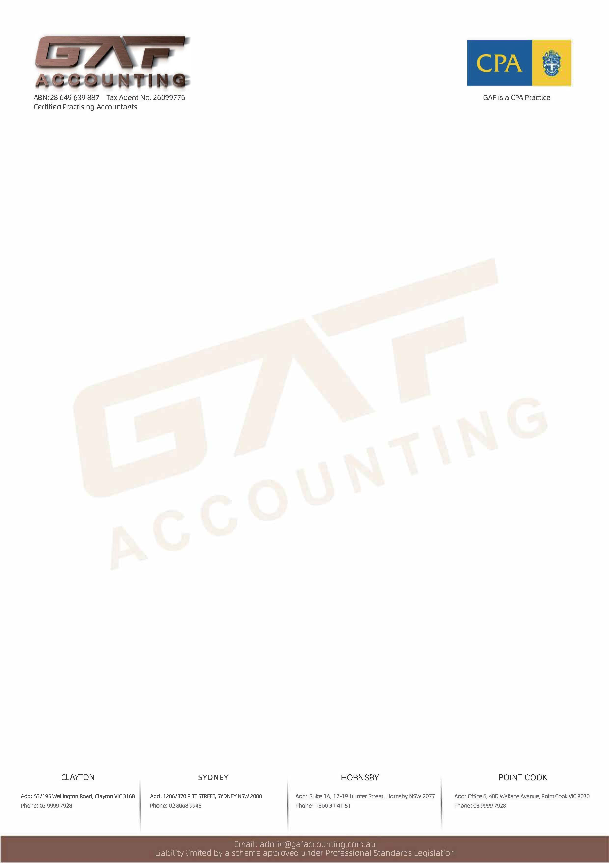

2024 Individual Income Tax Return Checklist
This checklist is for you to review, collect and submit your personal tax documents to our office for professional review. After it is completed, please attach any of your tax documents for the year and return to us

YOUR PERSONAL DETAILS

Title (Mr/Mrs/Miss/Ms/Dr)
Your family name
Your given name
Your current address
Your email
Your telephone number
TFN
Date of birth

BANK ACCOUNT DETAILS Please note the ATO requires every taxpayer provide their bank information
Account Name | BSB No. | Account No.

Has your address changed from last year’s tax return? Choose an Item
Have you been in Australia for a cumulative period of 6 months or more between 1 July 2023 and 30 June 2024? Choose an Item

Please enter the name/s of your spouse and dependent children in your care, their date of birth & incomes (if applicable).

Name | Date of Birth | Taxable Income for 2023FY (spouse) | Age (dependent children)

- INCOME

2024 PAYG payment summary (s) –If you were an employee during the 2024 financial year then scan and forward your PAYG payment summary (s) for each employer.
- Yes, I earned such income - then please send in relevant documents
- No, I did not earn this income

Other salary income -Did you receive any termination payments (e.g.: from leaving an employment), lump sum payments, director fees, commissions, etc.? If so, please send in the documents detailing the payment.
- Yes, I earned such income - then please send in relevant documents
- No, I did not earn this income

Interest - Did you earn interest income in any of your bank accounts during the financial year? If so, please attach the statement or amount of interest.
- Yes, I earned such income-then please detail below and send in relevant documents
- No, I did not earn this income

Dividends - Did you receive any dividends from shareholdings during the financial year? If so, please provide each dividend statement/s. We will summarise the dividends for you.
- Yes, I earned such income - then please send in relevant documents
- No, I did not earn this income

The table below is for your share of dividends. Please indicate jointly held shares clearly

Name of company | Jointly  held? | Date dividend paid | Unfranked amount | Franked amount

Capital gains/losses - Did you dispose or sell any investing assets (e.g. shares or property) that were acquired after 19th September 1985? If so, please use the schedule provided at the end of this document to provide details of gain/loss.
- Yes, I earned such income – then please send in relevant documents and complete schedule
- No, I did not earn this income

Employee share scheme or options or rights: Were you granted shares, options or rights during your employment from your employer during the 2024 financial year? If so, please email all documents, memorandums etc. Detailing the grant date, market value of share/right/option granted. Severe tax consequences can result if not reviewed.
- Yes - then please send in relevant documents
- No, I did not earn this income

Foreign income - Did you earn any foreign income during the 2024 financial year? For example, foreign investment property income. If so, please send in all documents detailing these earnings.
- Yes - then please send in relevant documents.
- If not an Australian tax resident for whole 2024 financial year, what date did your tax residency change: ___________
- No, I did not earn this income

Other income - Did you receive income from another source like:
- Managed funds – we require the annual tax statements please
- Partnership income
- Trust distributions – we require the statement of distribution
- Business income (if a sole trader for example)

If business income was earned then what is your sole trader ABN:__________________________
    - Did your sole trader GST registration status change during the year?
- Yes, I earned such income – then please send in relevant documents, excel files etc.
- No, I did not earn this income

NOTES: Please make any additional notes here regarding any other income earned

2. DEDUCTIONS

Motor vehicle - If you had to use your own vehicle for work purposes (and you did not salary package those costs) you will need to provide the details below. Check your prior year tax return for previous methods used. Provided below is detail of what we need.
Tip: If you incur tolls (city link) for driving then you need to assess the purpose of each trip before you can claim
2024 Motor vehicle expenses schedule Was your vehicle salary packaged? YES/NO

Registration number of the vehicle
Is the vehicle an electric vehicle (Plug-in hybrid vehicles is not EV)
Is this vehicle registered under your own name?
On what date was the vehicle purchased
Registration cost per year
Insurance cost per year
Repairs and maintenance cost per year
City Link/tolls
Depreciation/Lease payments/Hire purchase payments
Fuel cost per year
What was the date you last completed a logbook?
How many KMs did the vehicle drive during the financial year in total
How many WORK related kms did the vehicle drive during the financial year?
Multiply ATO rate 78 cents/kms (not EV)
Multiply ATO rate 4.2 cents/kms (EV)

- Yes, I incurred this expense – then please complete the schedule above & send in scanned receipts
- No, I did not have this expense

Work uniform - If you wear a uniform with a logo or use protective clothing (including boots) then please provide details of costs to purchase as well as any dry-cleaning costs. Sunglasses where you use them outside are also deductible.
- Yes, I incurred this expense - then please send in scanned receipts
- No, I did not have this expense

Taxation, accountancy & investment advice fees – Please detail taxation and investment advice fees (not all are deductible) including travel to and from our accounting office. We will input our fees, but you must advise of any others and attach receipts/invoices
Yes, I incurred this expense - then please send in scanned receipts
No, I did not have this expense

Travel for work - interstate or international – If you travelled for work purposes either domestically or
Internationally then we need the nights stayed, city and out of pocket costs.

Record keeping and substantiation - to claim a deduction for travel costs the following 2 conditions must be met:
- Written evidence must be obtained in respect of the expenses and
- “Travel records” must be kept where the travel is for 6 or more consecutive nights.

A “travel record” must contain:
1) nature of the activity 2) date and time of it, 3) how long it lasted and 4) location of the activity
- Yes, I incurred this expense - then please send in scanned receipts
- No, I did not have this expense

Interest on investment loans – If you borrowed to invest (for example to buy shares or investment property) we need the interest statement (s) forwarded to our office for each loan.
- Yes, I incurred this expense - then please send in scanned receipts
- No, I did not have this expense

Self-education – If you attended a formal course of education during the financial year then we will require the costs you have incurred to attend the course. To make a claim the following must apply:
- You attended a formal course of education during the financial year and
- The course has a sufficient connection to your current employment and
  - The course assists or maintains skills and knowledge specifically required for your current employment. Or
  - It will assist you to earn more income from your current employment then you can make a claim for self-education costs.
Write your amount next to the following expenses:

Note: any costs detailed here are independent and separate of other work-related deductions.
- Yes, I incurred this expense – then please send in scanned receipts
- No, I did not have this expense

1 | course fees
2 | enrolment costs
3 | books and journals
4 | library fees
5 | motor vehicle costs of driving to and from lectures etc.
6 | telecommunication costs to the extent they relate to the course
7 | interest on funds borrowed to pay for the course.
8 | depreciation on equipment used for the course
9 | home office costs (hours per week * weeks)

Personal superannuation contributions - If you made contributions please provide deduction notice (Section 290-170), and you received an acknowledgement from your fund.
- Yes, I incurred this expense - then please send in scanned documents.
- No, I did not have this expense

iPhone/iPad application costs – Many smart phones have the option of you purchasing applications for better efficiency and to enable you to carry out your work. To the extent they are used for work then the applications are tax deductible.
- Yes, I incurred this expense - then please advise us __% of work use and please send in scanned receipts.
- No, I did not have this expense

Income protection insurance premiums – are fully tax deductible and are a very smart way to protect your income. Did you have income protection insurance?
- Yes, I incurred this expense-then please send in scanned statement
- No, I did not have this expense
If you don’t have income protection insurance, did you know GAF Accounting can arrange for a free quote? Please email us for a free quote

Donations – please detail below and provide copies of receipts

Name of charity | ABN | Amount of donation

NOTES:Make any additional notes here please regarding deductions and schedule at back for more work-related items

Other work-related expenses
Name of expense | Total cost | Work related % | Amount to claim
Award overtime meal allowance
Books, journals, magazines for work or investment purposes
Computer expenses including depreciation
New equipment bought date & amount
Home office – hours per week you do work activities at home (ATO revised fixed rate $0.67/Hour)
NOTES for HOME OFFICE – FIXED RATE METHOD (if using $0.67/hour, you CANNOT claim electricity/water/gas/mobile/printer ink and paper/internet BUT depreciation expenses) see below ATO link: Fixed rate method - 67 cents | Australian Taxation Office (ato.gov.au)
Newspapers for work activities
Printing Postage and Stationery
Covid Rapid Test Kit/PCR Test
Subscriptions to work related publications
Telecoms – mobile phone
Telecoms – internet
Telecoms – iphone/ipad data cost
Work materials and tools
Equipment
Professional Association membership fees/union fees
Other (please specify)

3. PRIVATE HEALTH INSURANCE
Private health insurance – Please provide the end of financial year membership statement.
Yes, I had private health insurance for Hospital Cover
No, I did not any have private health insurance or my private insurance did not have Hospital Cover
NOTES:
1) you must have hospital cover.If you only have Extra Cover and or ambulance Cover,please tick “NO”.
2) Private health insurance with hospital cover is not deductible expense. Instead,
3) Private health insurance will reduce your medicare levy surcharge
4) More details of medicare levy surcharge please refer ATO:
https://www.ato.gov.au/Individuals/Medicare-levy/Medicare-levy-surcharge/?anchor=IncomeforMedicarelevysurchargepurposes#IncomeforMedicarelevysurchargepurpo

4. INVESTMENT ASSETS

Investment property - these are especially highlighted as they require extra details. Otherwise, please provide Annual Rental Statement, Loan Interest Summary, or Depreciation Report.

Worksheet: | Investment property schedule 2024

Property Address:
Percentage ownership: |  | Property Loan refinanced? | YES / NO
Weeks rented? |  | Date 1st rented?
Income | Document reference | Amount
Income received during the financial year
OR please provided Agent Annual rental statement
Property Acquisition & Disposal Date Amount
Acquisition
Disposal
Expense Description | Date incurred/Notes/Loan account numbers/Invoice reference | Amount
Advertising for tenants
Body corporate fees
Borrowing expenses
Cleaning
Council Rates
Depreciation Transferred
Gardening and Lawn Mowing
Insurance
Interest on loans (you must provide bank statements)
Did you refinance or top up from the investment loan in 2024FY? | If yes, please provide new investment loan application and statement. | Y/N
Land Tax (provide Statement)
Property agent Fees/commission
Repairs and maintenance
Stationery, telephone and post
Water charges
Other
Any queries or questions? Please call 03 99997928. Please attach all receipts and invoices detailing deductions

We also need details of any new capital equipment purchased during the financial year for the investment/rental property – the item purchased, date purchased and cost is required.

Date of purchase | Description of item | Cost

5. CAPITAL GAIN/LOSSES:
When you sell an asset, you need to calculate the capital gain or loss. For each asset, you have sold in 2024 please detail the following: (Eg: shares, investment property and cryptocurrency trade)

Description & name of asset

Date of purchase – contract date

Date of sale – contract date

All purchase and sale related documents provided?

