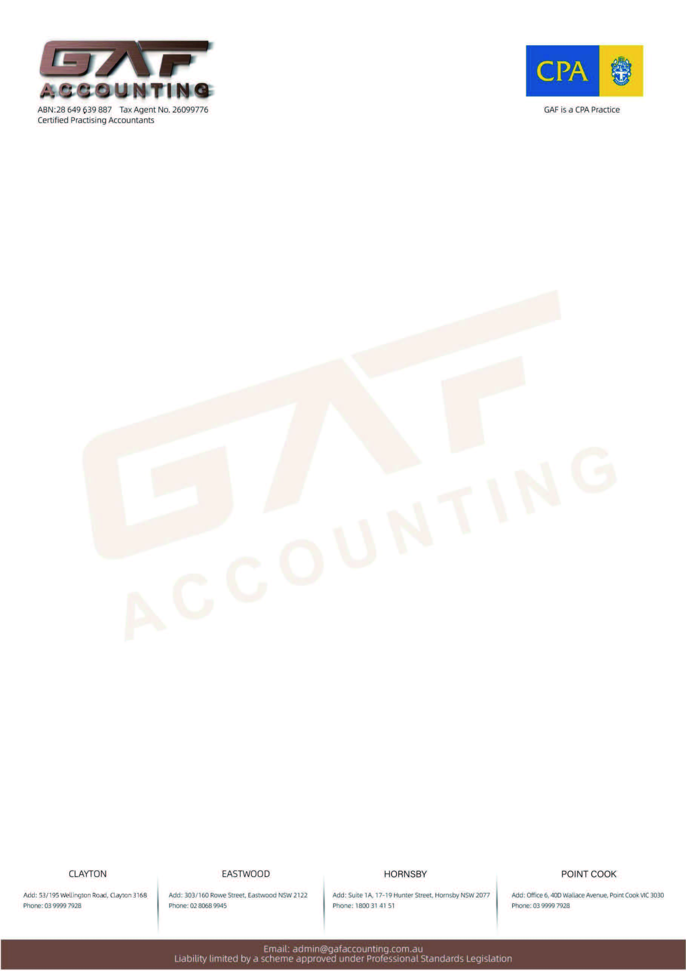
Company Registration Form
Client Information Filling Date: .
Entity details
Name of the Australian Private Company  （In order to avoid repetition of the enterprise name, please provide 3 different name for us to select.） |  | 1.  2.  3.
Company Structure  (Select one☑) | ☐Company ☐☐Partnership  ☐Family Trust ☐☐Discretionary Trust  ☐Uni Trust ☐ ☐Other .
Company postal address (*If the client accepts the address of GAF Accounting Pty Ltd as postal address, the information as follows does not need to fill in.)
Street 1 *: Street 2: Suburb: .
State: Postcode: Country: .
Telephone number (Company) : .
Email Address (Company) : .
Main business address
Street 1 *: Street 2: Suburb: .
State: Postcode: Country: .
Telephone number: .
Service Email Address: .
Business Activity details
require date：
Main business activity description：
How many people are consenting to be the director? Provide each directors information as follows:
Associate details
Associate individual select ☐1.， Associate Organization select☐ 2.
☐1. Associate individual (If associate individuals are more than two, please filling the remaining information in APPENDIX.
Associate individual 1:
Title |  |  |  |  | First given name |  |  |  |  |  |  |  |  | Other given name
Family name |  |  |  |  |  |  |  |  |  |  | Position held |  |  |  |  | ☐Director ☐Public officer  ☐Shareholder ☐Secretary  ☐Other .
City of Birth
Date of Birth |  |  |  |  |  |  |  |  | Sex |  |  |  |  | Tax file number
Postal Address
Telephone number
Associate individual 2 (If have):
Title |  |  |  | First given name |  |  |  |  |  |  |  |  |  |  | Other given name
Family name |  |  |  |  |  |  |  |  |  |  | Position held |  |  |  |  | ☐Director ☐Public officer  ☐Shareholder ☐Secretary  ☐Other .
City of Birth
Date of Birth |  |  |  |  |  |  |  | Sex |  |  |  |  |  |  | Tax file number
Postal Address
Telephone number

☐2. Associate Organization
Organization Name
ABN of associate organization
ACN of associate organization
Tax file number |  |  | Position held
How to divide shares? Ratio of each director holds
Need a hard copy for Company Registration $49.5? Or Company Seal $38.5?

Reason for application (Select one☑)
☐New business in Australia
☐Investment purpose
☐Purchased Existing Business
☐Contractor
☐To receive payment for service
☐Change in business structure

APPENDIX:
Associate individual 3:
Title |  |  |  |  | First given name |  |  |  |  |  |  |  |  | Other given name
Family name |  |  |  |  |  |  |  |  |  |  | Position held |  |  |  |  | ☐Director ☐Public officer  ☐Shareholder ☐Secretary  ☐Other .
City of Birth
Date of Birth |  |  |  |  |  |  |  |  | Sex |  |  |  |  | Tax file number
Postal Address
Telephone number
Associate individual 4 (If have):
Title |  |  |  | First given name |  |  |  |  |  |  |  |  |  |  | Other given name
Family name |  |  |  |  |  |  |  |  |  |  | Position held |  |  |  |  | ☐Director ☐Public officer  ☐Shareholder ☐Secretary  ☐Other .
City of Birth
Date of Birth |  |  |  |  |  |  |  | Sex |  |  |  |  |  |  | Tax file number
Postal Address
Telephone number
Associate individual 5 (If have):
Title |  |  |  | First given name |  |  |  |  |  |  |  |  |  |  | Other given name
Family name |  |  |  |  |  |  |  |  |  |  | Position held |  |  |  |  | ☐Director ☐Public officer  ☐Shareholder ☐Secretary  ☐Other .
City of Birth
Date of Birth |  |  |  |  |  |  |  | Sex |  |  |  |  |  |  | Tax file number
Postal Address
Telephone number

