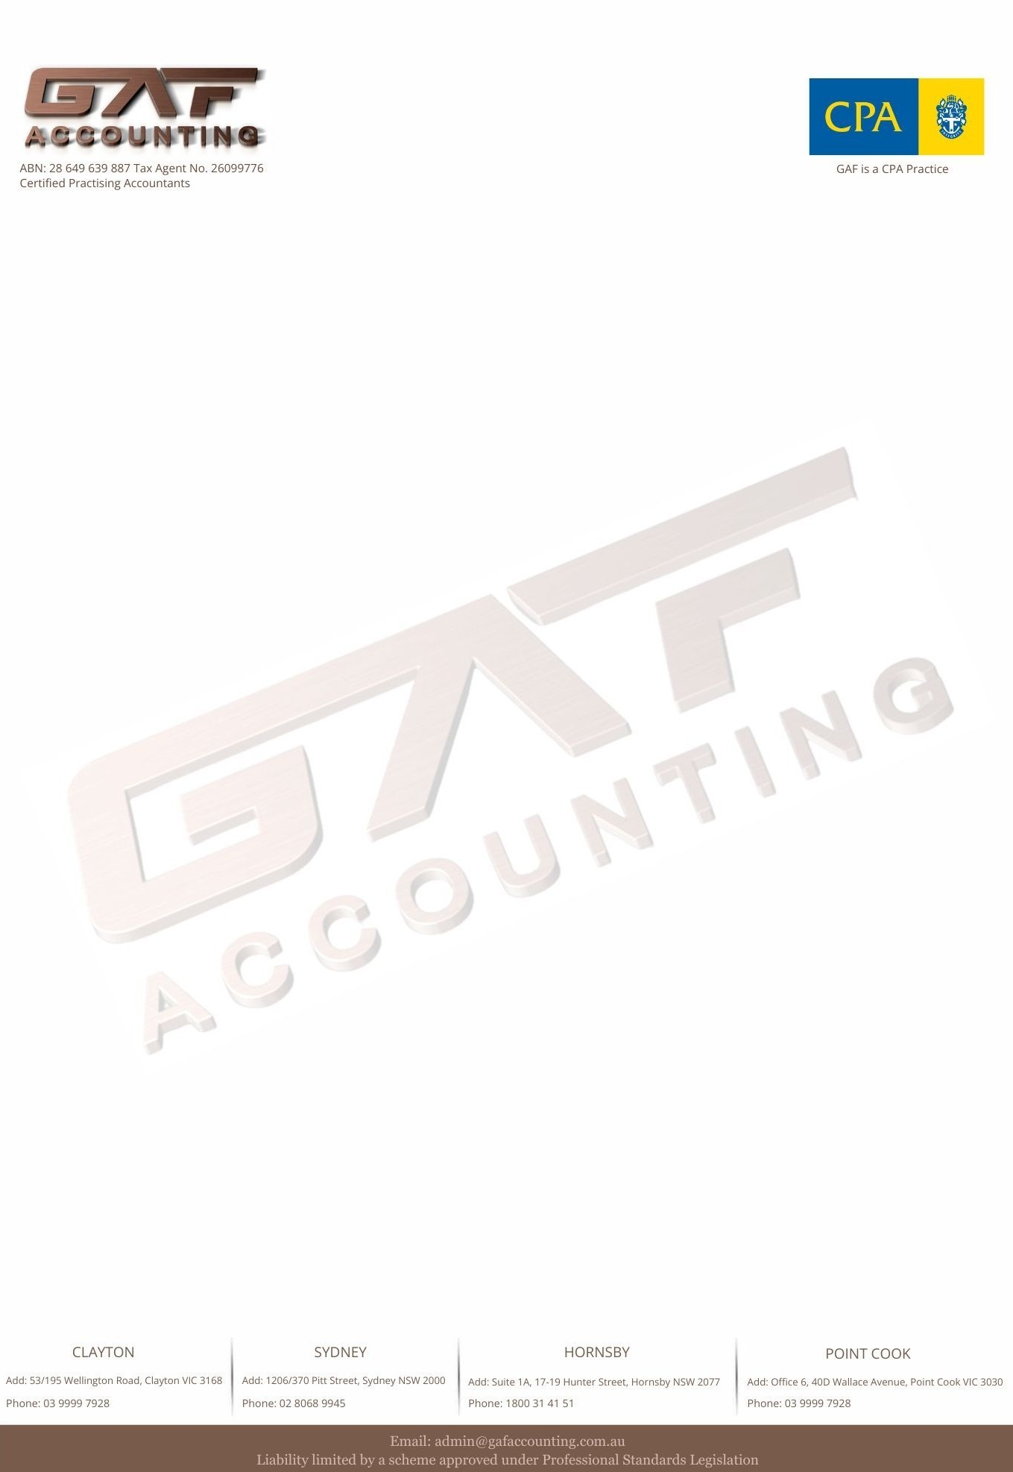

Checklist - Business Activity Statement (BAS)
A BAS (Business Activity Statement) checklist is typically used by businesses in Australia to ensure they are fulfilling their tax obligations, specifically for GST (Goods and Services Tax), PAYG (Pay As You Go) withholding, and other relevant taxes. Here's a basic checklist to help you with BAS preparation:
Contact Name: | Business Name:
Business Address:

ABN (Australian Business Number) : | TFN (Tax File Number):
Contact Details: | Email Address:
Information Belongs to: | Choose an Item
Business Details:

Documents for BAS Preparation:
Backup of Data Files:
- Please provide a backup or export of your data file |  | Choose an Item
Accounting Software:  Choose an Item  Other: | Version number of the software: | Login & Password details (If required):
- Bank Statements:  Copies of all bank statements showing opening and closing balances for the quarter. |  | Choose an Item
- Invoices for Income:  Provide copies of all invoices issued to customers for the period, organized in date order. |  | Choose an Item
- Payment Receipts for Purchases:  Provide copies of all payment receipts for expenses (including purchases and asset acquisitions), in date order. |  | Choose an Item
- Loan Schedule:  Provide a loan schedule if applicable (e.g., business loans, vehicle finance, equipment leases, etc.). |  | Choose an Item
Additional Comments/Notes:

Please note: If the information provided is insufficient, we may request additional documents or details. Providing accurate and complete information will ensure the BAS preparation is efficient and correct, helping you meet your obligations and avoid delay.

